Report on
“State Level Conference cum Workshop on Pre Conception and Pre Natal Diagnostic Techniques, 1994”
Programme venue: Tribal Research Centre, Morabadi,Ranchi.
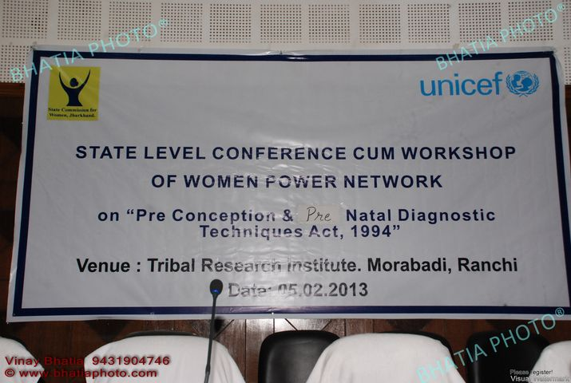
Date:5th feb,2013

Presented by:
State Commission for Women, Jharkhand
Documented by: Ms Rani Kastury

Introduction:
The State Commission for Women, Jharkhand in collaboration with UNICEF, Jharkhand organised a State Level Conference Cum Workshop on Pre Conception and Pre Natal Diagnostic Techniques, 1994 on 5th Feb 2013 at Tribal research Institute ,Morabadi, Ranchi, Jharkhand.

The workshop was graced by following distinguished Guests and dignitaries:
- Dr Hemlata S Mohan, Chairperson, State Commission for Women, Jharkhand
- Mrs Mridula Sinha, Prinicipal Secretary, Social Welfare. Women & Child Development Department
- Mr. Job Zacharia ,Chief , Unicef ,Jharkhand

Opening Address: Dr Hemlata S Mohan, Chairperson, State Commission for Women, Jharkhand
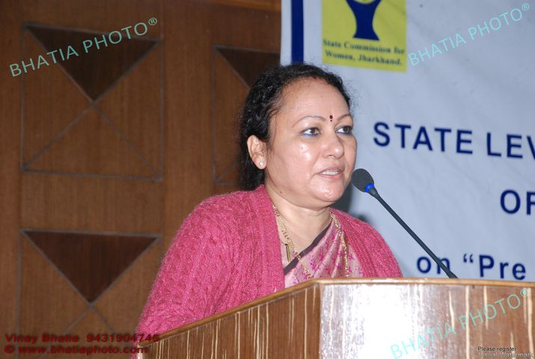
Addressing the participants and the dignitaries, Dr. Hemlata S. Mohan said that now is the opportune time to awaken ourselves and take concrete actions. The rise in female infanticide and the falling trend in the sex ratio are at alarming levels. In this area development agencies as UNICEF and Plan India are playing important role. The state-Department of Women and Child is also playing its crucial role at policy levels and under the various programmes and schemes. Parallel, the society also has to come to the forefront and take responsibility in working towards achievement of the society free from gender bias and gender discrimination which promotes such evils as female foeticide. Through concerted and joint efforts of all the stakeholders, the decline in the sex ratio (proportion of male to female per thousand) can be minimised. Use of Sex selection techniques before birth to ascertain the sex of the unborn child raises a question mark on the existence of the women and girl child.
Now the intervention has to reach at the grassroots levels where all the stakeholders has to play an active role in creating and raising awareness on the alarming state of affairs and the resultant effects of the declining sex ratio and work towards bringing a change in the mind-set and attitude of the people for gender just society devoid of gender based crimes and discrimination. This ongoing workshop will be followed up with more capacity building interventions focussing CDPOs, department officials and the newly elected representatives of the Panchayati Raj Institutions in Jharkhand. To effectively implement the PCPNDT Act, 1994 our first priority is to work towards achieving a sensitized society which can be realised by creating awareness at all levels. A healthy society is built upon principles of equality and equity which respects its women and girls. The responsible citizens of the society will have to take the initiative in this direction for mass awareness.
Bringing in focus “Women Power Network” the state level network created by the Commission, Dr Hemlata S Mohan (Chairperson) informed that information was solicited from the various departments-state and district. The commission is working towards making the Network online along with the information more user friendly. Based on the response received from districts it is not a positive scenario as only few districts (5-6) reported on the information asked. Apart from the Civil Surgeons, support from the NGOs was also elicited. If the information were received from all then the commission would have taken the initiative to make all the information accessible online through its website(www.jscw.in). Such information, if available, will help in exercising pressure on the unregistered pvt. Ultrasound clinics. To strengthen and activate the Women Power Network in all the 24 districts, regular communication was initiated and taken up but it will take more time to see visible change.

While praising the Deogarh SP ,She said that he has opened the women protaction cell with the help of CDPOs,SAHIYA,Anganbadi sahayika etc.He has created an environment and getting necessary information with the help of Women protection cell .These examples gives us lesson.we should realize our responsibility and co-ordinate with each other.If we want to give strength to the WPN then there is need to make co-ordination in between CDPO,BDO,SAHIYA and PRIs,from these co-ordination result will always positive.When females are pregnant then their family create the pressure on them for sex selection test,for them we should take action ,we are ready take big steps in this area.She said that until we don’t do the work with determination and honesty,our aim/goal will be not fulfil/cannt be achieved.Our goal is not easy, need to chage in mentality and thoughts of society.She said that a famous writer Dushyant said that “Kaun kahta hai asman me surakh nahin ho sakta,Ek pathar to tabiyat se uchchalon yarron”Deffinately we will achieve our goal.

- Job Zakaria,Chief ,UNICEF,Jharkhand:-

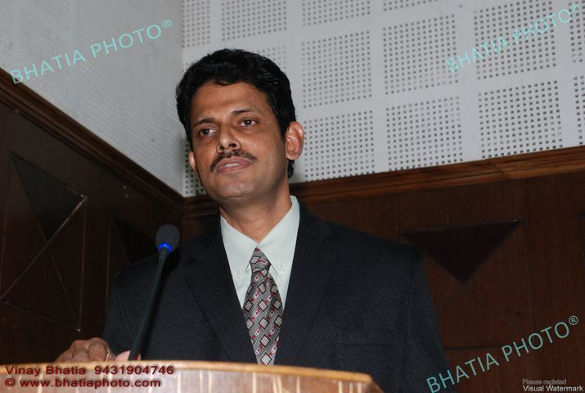
Special Guest Mr. Job Zakaria, chief, Jharkhand expressed his concern in the area of declining sex ratio and child sex ratio. He said that in India, sex selection test is legally prohibited. PCPNDT (sex selection prohibition test) Act is specially a law for prohibiting the sex selection, but due to various reasons that Act has not been very effective. As per the report of United Nations, in our country every year 5.5 lakhs girl child are killed before their birth. In Jharkhand every year 11,000 girls are killed before their birth. In past, the average sex ratio in the state was more than the national sex ratio, but now it is rapidly declining. There is a decline of 21% in the sex ratio from the year 2001 to 2011. The situation is more deteriorating in the urban areas where it has registered a decline of 69 points. The situation has worsened in the districts of Bokaro, dhanbad, East Singhbhum, Hazaribagh, Ramgarh, Ranchi and Giridih.

Mr. Zakaria said that we all are well versed with the state of affairs but the problem presented in front of us is what we can do about it? Actually the underlying issue is to change the mind-set and attitude on the rights of the women of the family and society. The existence of the male dominating society, we have to raise ourselves above it. Laws has been enacted to abolish child marriage, domestic violence, child labour but this alone will not bring about changes unless we bring about change in our thinking and attitude. Only enactment and implementation of PCPNDT Act will not attain the objective but other laws on child marriage, Dowry practice, and child labour also need to be strongly implemented effectively. Jharkhand launched the programme on Save Girl child in the year 2012.We should welcome such initiatives and such work should be taken forward.

Mr. Zakaria expressed his worries that in our state health services are not up to the mark as per need. There is shortage of doctors, we have approximately 3000 doctors consisting 2000 govt and 1000 non govt 3000 doctors are here, In which 2000 are govt. and 1000 are pvt. If the doctors take the decision that no more pre conception and prenatal sex selection tests will be conducted then it will go a long way in the betterment of the society. Parallelly, police, local administration, Panchayat representatives, Sahaiyya, NGOs and the society has to come forward and take initiative in this direction. With the close cooperation and coordination of all stakeholders definitely pragmatic results will be

- Mrs Mridula Sinha,Principle Secretory ,Social Welfare & Child & Women Welfare,Department,Jharkhand:

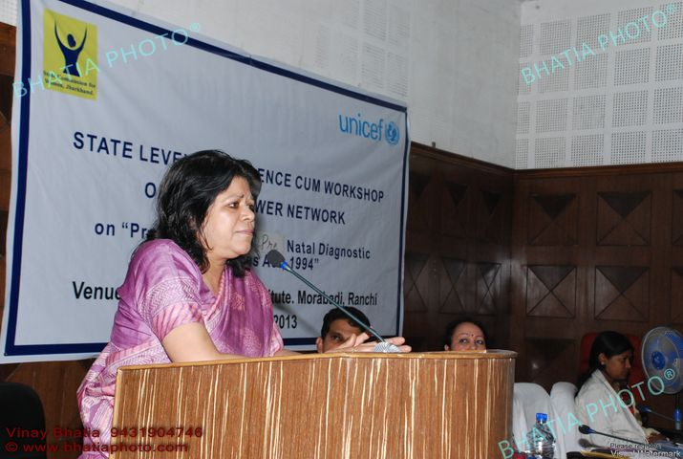
Distinguished Guest Mrs Mridula Sinha, Secretary of Social welfare department, Jharkhand said that our mentality has not changed till now even with industrialization and advancement .On sex determination and sex selection, conservative thinking and narrowness is intact. Where society is educated and families are educated they are also doing this unprecedented crime and those who don’t need this they are also searching for this. She said that Jharkhand is not like Haryana but not far away from this also .In our locality so many unregistered USCs are present but we are not showing our responsibility to stop them. There are many such example in big cities like Ranchi, Dhanbad, Hazaribagh, Jamshedpur etc. We need to change our mentality. The families who commit should be boycotted from the society. .Being silent is dangerous. The family of rape victims keep silence and due to social pressure they don’t come in outside to seek justice. In this situation along with society we are also the culprit .After the incidence of 16th December in Delhi it brought about a mass awareness. Now is the correct time to change the mentality in favour of girls. She said that implementation of PCPNDT act is not too tough but for this doctors should be ready with the confidence of the Indian Medical Association, because if doctor are not ready for this then that it will not happen. Parallely other women friendly las such as Prevention of Child Marriage Act, Domestic violence Act and dowry prohibition should also be implemented effectively to bring about a holistic change .In the state 712 sex detection centres are available, many are unregistered test centres , we need to monitor every one of them. Social awareness is the only way to effectively implement the PCPNDT Act.

2nd session of programme:
The IInd session of the programme started after Tea Break. This session focussed on the Provisions of the Act, the mechanisms and systems that have provided under the Act at the state and district level.
- PCPNDT Act,its provision and its status of implementation in Jharkhand.
- Inter state cross learnig :Status review:Jharkhand vis a vis other states:Uttrakhand.
- Role of women power network and districts health administration:As facilitators in implementation of PCPNDT Act,1994.
Resource Persons were:-
- Ms. Debjani Khan,Project Manager,Plan India
- Ms. Saroj Naithani,State Nodal officer,Uttrakhand
- Ms. Madhulika Jonathan,Unicef ,Jharkhand

- Ms. Debjani Khan Project Manager ,Plan India:

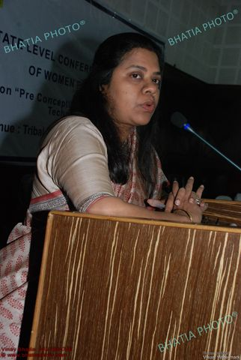
Ms. Debjani Khan, Project Manager ,Plan India, started the 2nd session of Programme. She shared with the participants about the PCPNDT Act, its provision and the status of implementation in context of Jharkhand state. She emphasized that in order to effectively implement the PCPNDT Act, we need to focus on various aspects. Amongst them issues such as migration of girls, health status, Poverty and lack of appropriate avenues of livelihood are also need to be addressed. Another underlying reason for the state of affairs is the patriarchal society and preference for the male members in the family. The resultant effects are 22% decline in the sex ratio from 2001 to 2011( Sex Ratio in 2001-965 per thousand males and in 2011, sex ratio came down to 943 per thousand males).In the last three decades, approximately 12 lakhs girls were killed before birth. This was attributed to the conservative nature of society which is augmented by the role played by the service providers such as Gynaecologist Radiologist, Sonologist and others.
In continuance to her discussion, it was shared that in the state of Maharashtra a PIL was filed to fix accountability for pregnant mothers and for safe and security of motherhood in the year 1991. Thus, going through various stages, the present form of PCPNDT Act is enacted and implemented. As per the provisions of the Act, neither sex of the baby can be known nor selected. The PCPNDT Act is different from other social Acts as it does not legislate for social behaviours and social changes but it advocates for ethical norms to be followed in practice of health service delivery and in the use of techniques. This Act is not meant for implementation on the society but it is enacted for providing total security of the pregnant women. Ms Khan also focussed on the following areas of the Act:
- As per provision of this Act anyone including the husband, family and relatives cannot exert pressure on pregnant women for sex selection test or usage of any sex selection techniques. This can be done only under special medical cases it’s allowed in only in some medical case.
- To regulate the law at the state level, State Appropriate Authority have the responsibility.
- At the district level, the Civil Surgeon has the responsibility to implement the Act.
- In the context of this Act, it is interesting to note that in case of complaint for violation of the provisions of the Act, an FIR cannot be lodged against anyone. If there has been an instance of a pregnant lady being forcefully subjected to sex selection then no action can be initiated against the responsible person.
- On the event of complaint for violation of the Act or its suspicion , help can be taken from the local police, civil surgeon and the local administration.
- Regular interaction and support of the Sahaiyya can be taken in such cases as she is well versed with the area of her work and she has all the requisite information and details of pregnant women and mothers in her work area. The help and support of the PRI elected representatives can also be taken in such matters.
- Emphasizing on the need for sensitization of the society and for change in the mind-set of the people, Ms Khan said that positive trends such as celebration of the birth of a girl child should also be done as is done in case of a male child.
- There is also a need to fix the accountability of the doctors. There are unfair practices where doctors advise for ultrasound to be done without establishing the need for the same whereas only authorised person such as radiologist, MBBS doctors can only advise for such tests.
- As individuals, our responsibility is to proactively report such matters if on-going and bring it to the light of the appropriate authorities.

Presentation given by:Ms. Debjani Khan

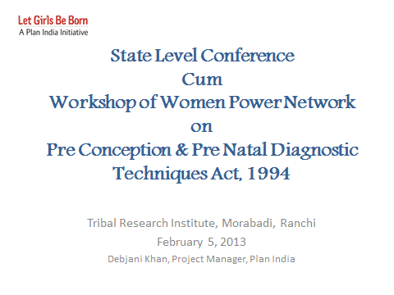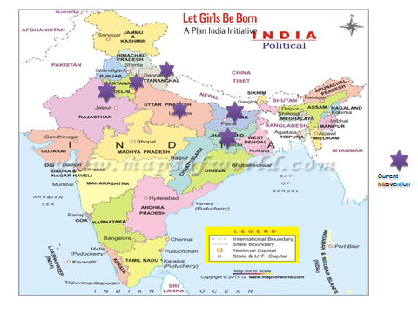
Slide :-1 Slide:-2

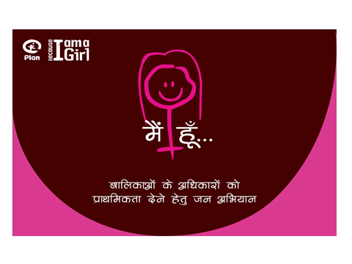
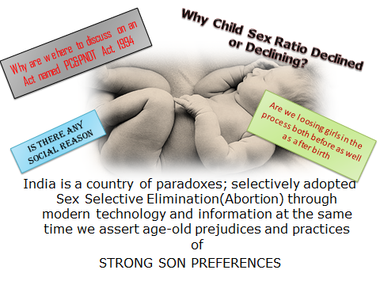
Slide:-3 Slide:-4
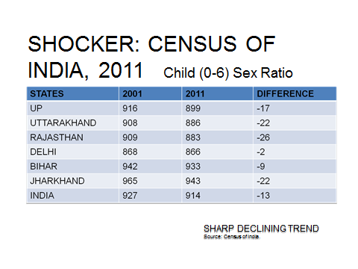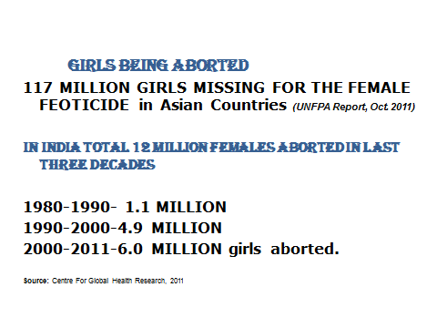
Slide:-5 Slide:-6
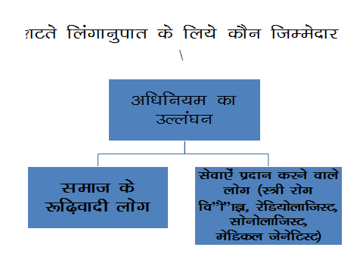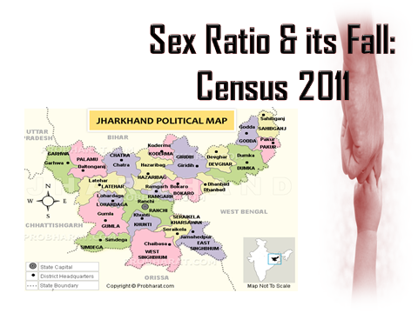
Slide:7 Slide:-8
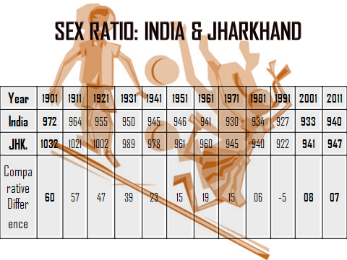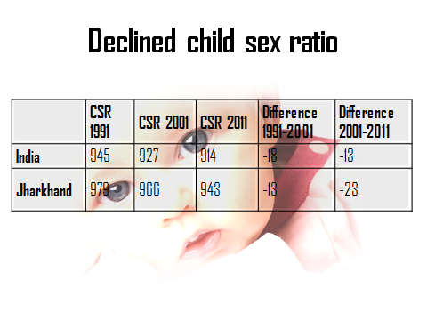
Slide:-9 Slide:-10
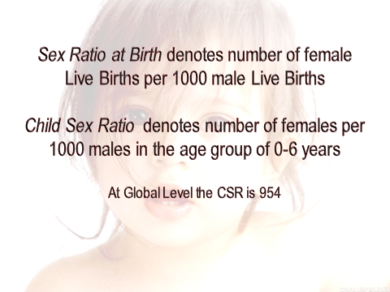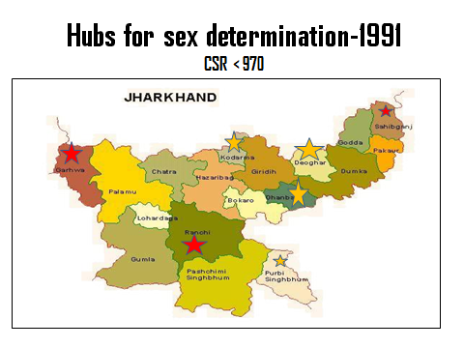
Slide:11 Slide:-12
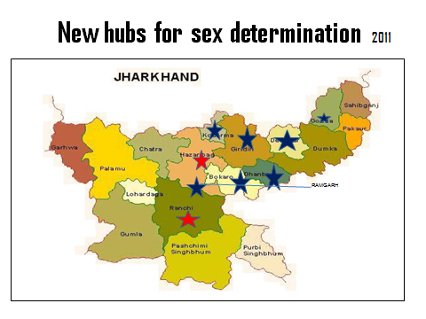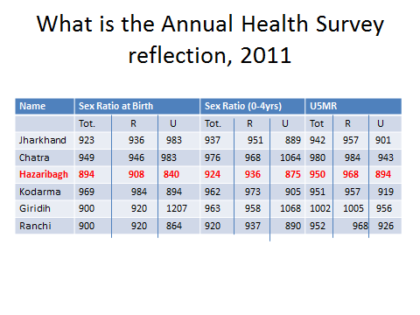
Sliide:-13 Slide:-14

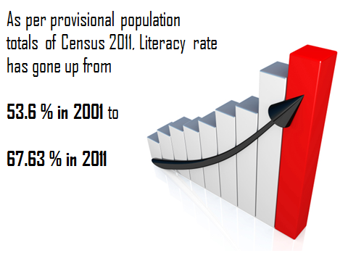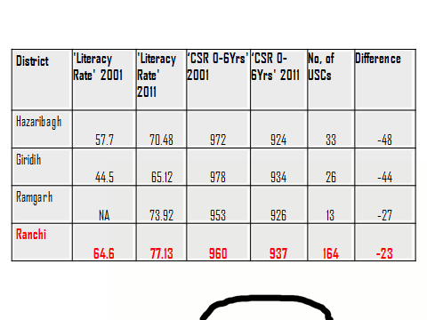
Slide:-15 Slide:-16

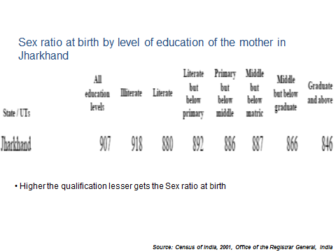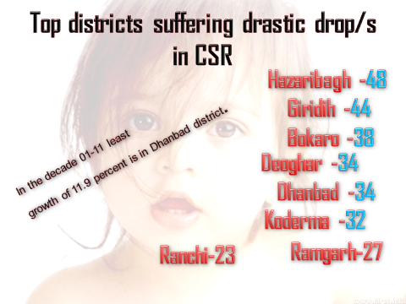
Slide:-17 Slide:-18
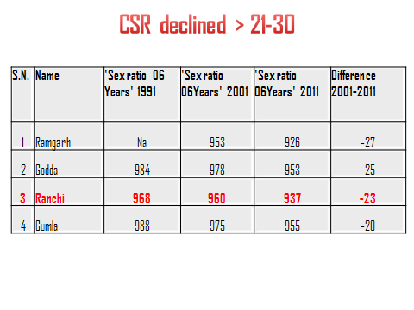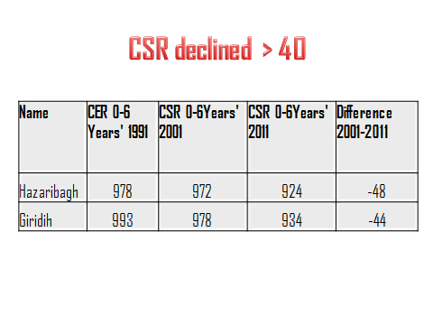
Slide:-19 Slide:-20
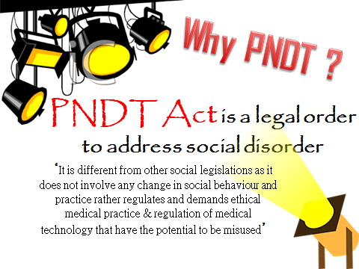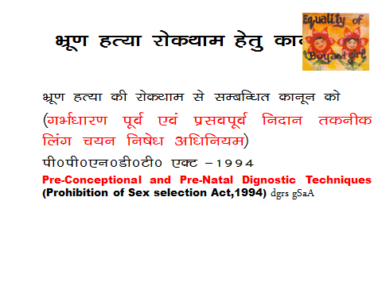
Slide:-21 Slide:-22
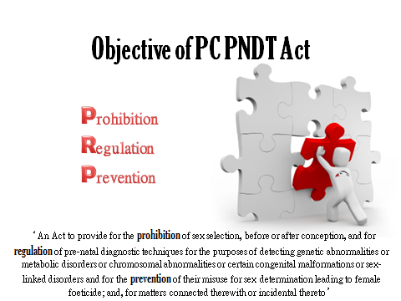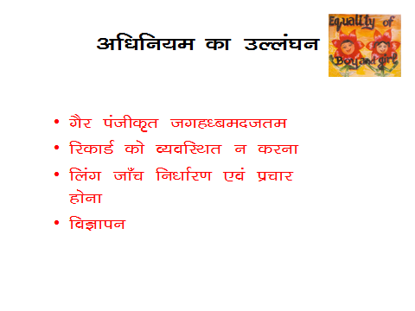

Slide:-23 Slide:-24
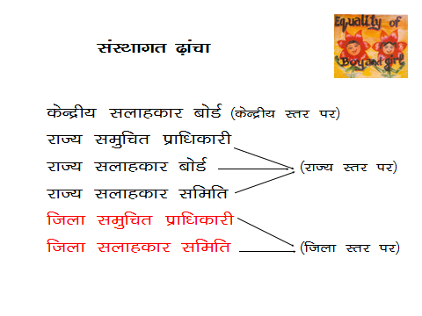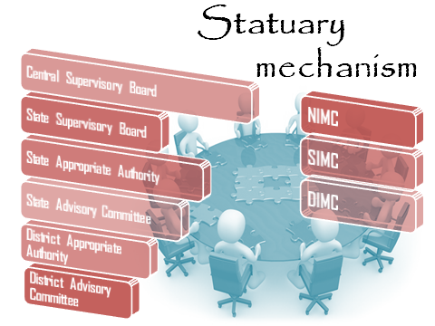

Slide:-25 Slide:-26

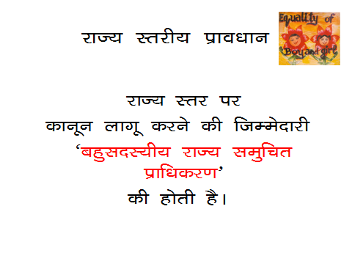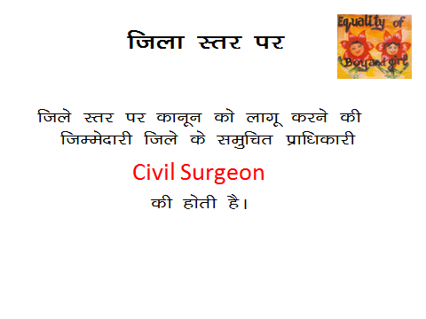
Slide:-27 Slide:-28
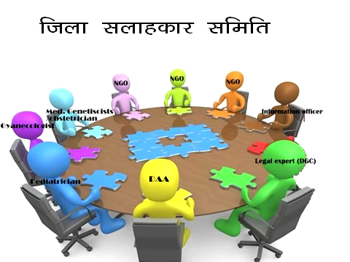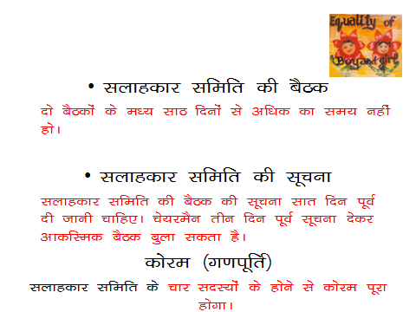

Slide:-29 Slide:-30
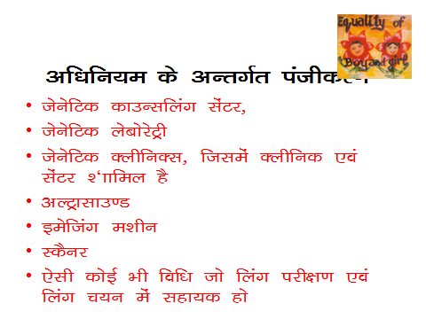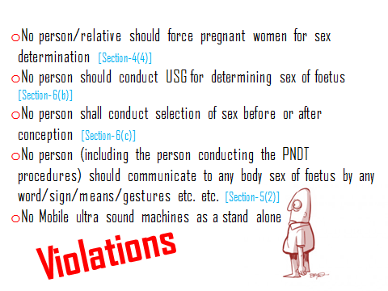
Slide:-31 Slide:-32

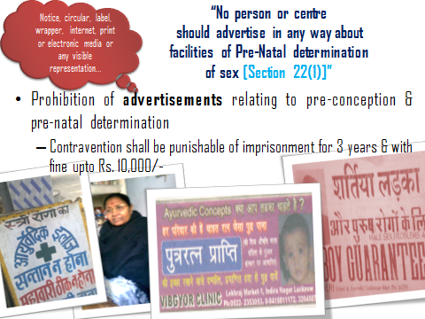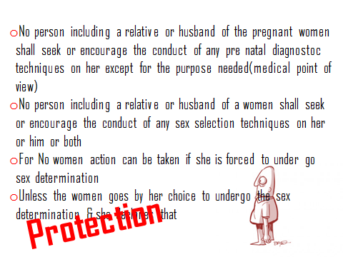

Slide:-33 Slide:-34
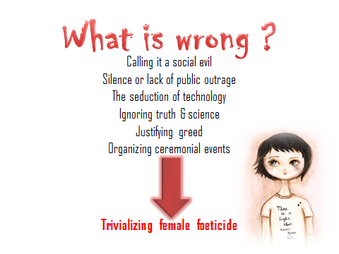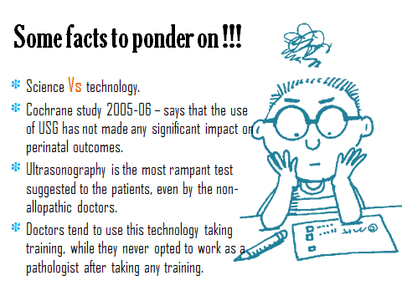
Slide:-35 Slide:-36

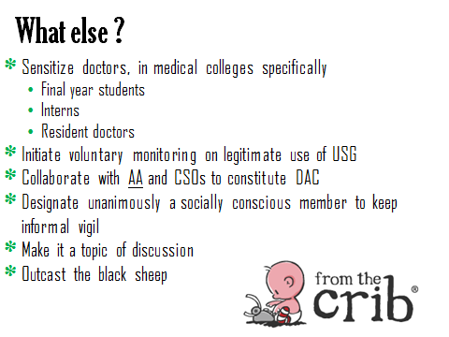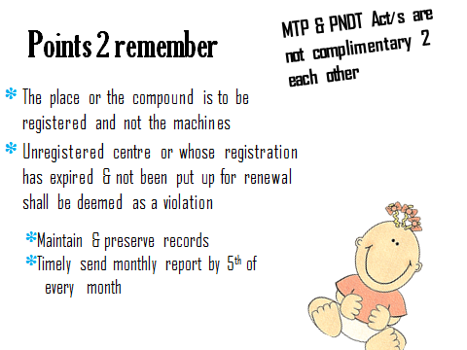
Slide:-37 Slide:-38
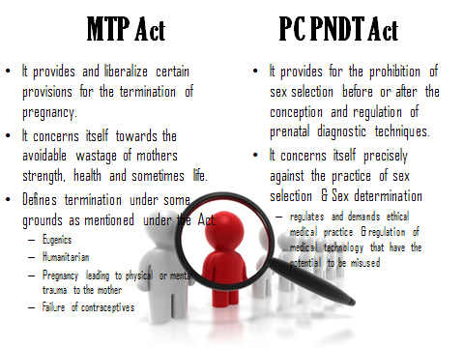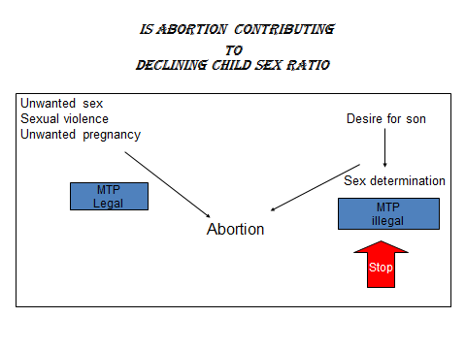
Slide:-39 Slide:-40
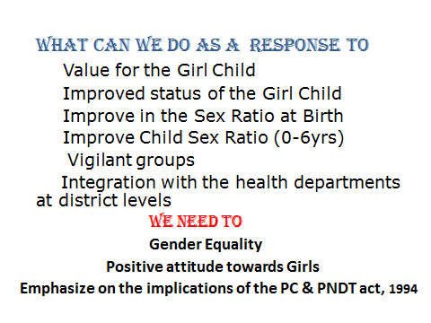
Slide:-41 Slide:-42

- Ms. Saroj Naithani,State Nodal Officer,PCPNDT Cell,Uttrakhand:-
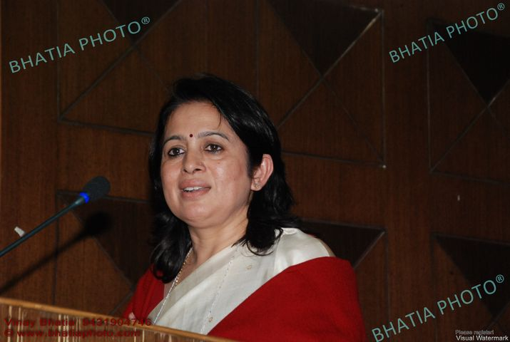
Focussing on the state of Uttarakhand, Dr Naithani informed that the state consists of 13 districts. Geographically all the districts are hilly areas apart from Nainital district. In comparison to the census of 2001, there are only 850 girls per thousand male as per the census of 2011, which is below the national average of 954.

Few facts and figures of the state:
- In the state of Uttarakhand there are 518 registered Ultrasound Clinics but in reality the actual numbers is more than 40 times than the reported figures.
- Such mechanism has been developed in the state which provides for all information pertaining to pregnant women on a regular basis. For instance if a pregnant women undergoes ultrasound test, then detail report card giving information of the pregnant women, address details, name and address of the centre where test was done is generated and collected for follow up.
- As per the need, the DC and the DM are appointed as Appellate Authorities. The chief of the Supervisory Board is the State Health Minister. Accordingly at other levels appropriate officials and NGOs have been incorporated.
- On the PCPNDT Cell of the State, Dr Naithani informed that orientation and capacity building of the members of the cell has been done on the Act, its related provisions.
- Training has also been conducted for Doctors, Radiologist, and Gynaecologists for online filing of various compliances forms.
- The process of providing training to all the ASHA and Sahaiyyas is ongoing.
- Efforts are on-going for incorporating all the vendors and sellers of Sonography machines to this training programme. All the related information on the sale and purchase of such machines at any levels to be readily available and accessible through online.
- For raising awareness of the public, activities such as Radio Jingles, Songs, awareness and advertisement through mobile vehicles. Through awareness messages and advertisement on Newspaper, TV channels efforts are taken to stop female foeticide and also to provide motivation to girls and women.
- Dr Naithani shared that planning is also done to aware and train the students of 52 government colleges of the state to sensitize the youths. These are also done by events such as celebrating Youths Day and Women’s Day.
- Inspection of such Ultrasound centres conducting sex selection tests is also emphasized upon. Under this, SIMC conducted campaigns in 4 districts-Haridwar, Chamoli, Rudraprayag and Paudi where 6 machines were sealed. In total till date 17 machines has been sealed, 30 centres licence has been revoked and Court case hearings are ongoing in 5 cases.
But the existing state of affairs demands for more action. We need to undertake our roles and responsibilities more sensibly.
She focused on important points for implementation of PCPNDT act and to stop the foeticide.
- Need for regular monitoring of the child sex ratio (0-6 yrs)
- Implementation of the provisions under the MTP Act in practice.
- Along with MTP Act regular maintenance and updating of the abortions related data
- Developing online system of filing of form F.
- Appropriate arrangements for security in cases for victims.
- Use of Active tracker device in every US machine.
- Regular inspection of ultra sound centres.
- Regular monitoring of Ultra Sound Centres.

Presentation given by : Ms. Saroj Naithani

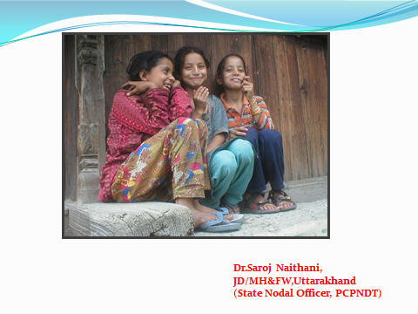
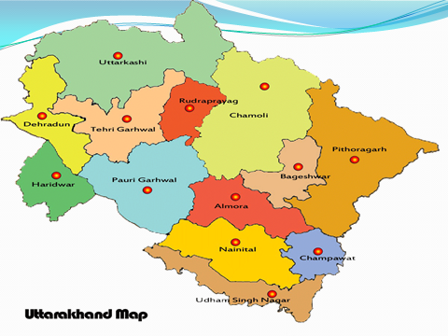
Slide:-1 Slide:-2
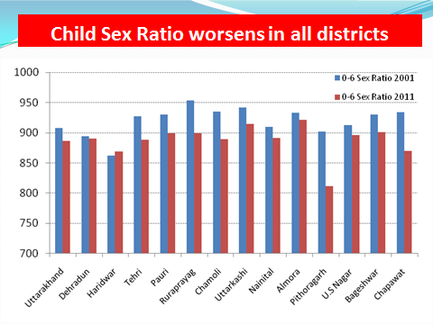
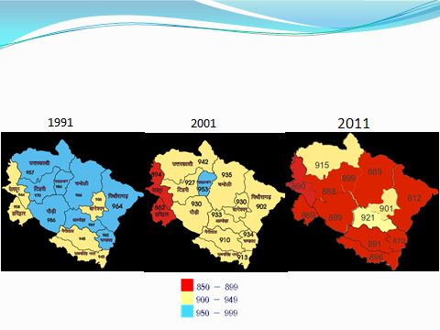
Slide:-3 Slide:-4
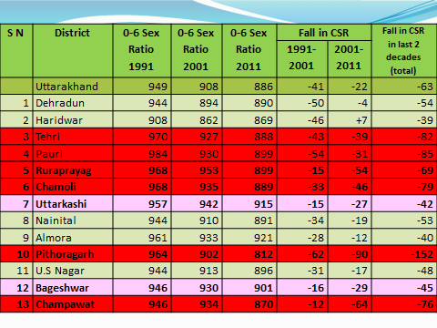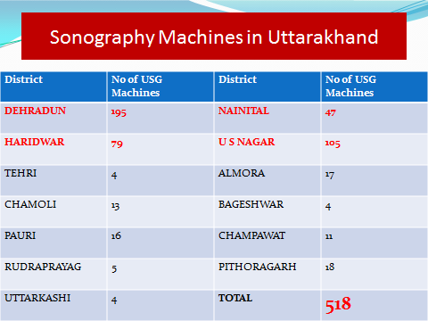
Slide:-5 Slide:-6
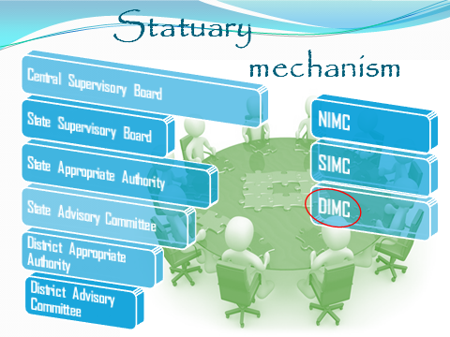
Slide:-7 Slide:-8
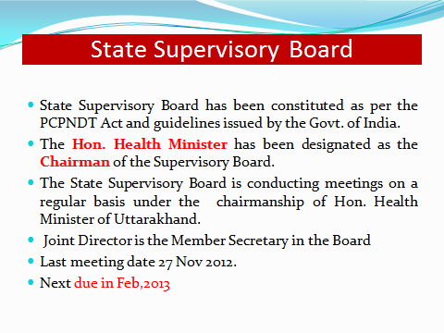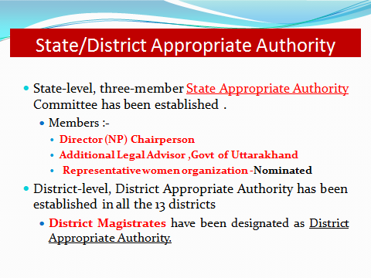
Slide:-9 Slide:10
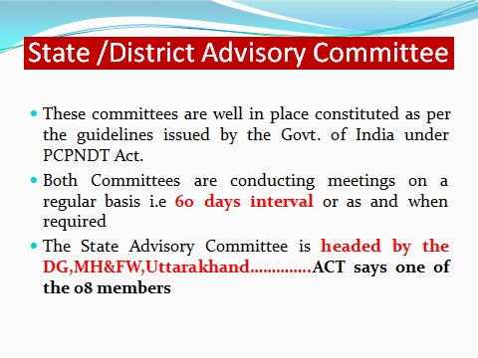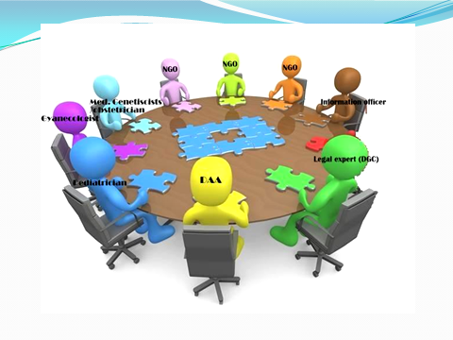
Slide:11 Slide:12
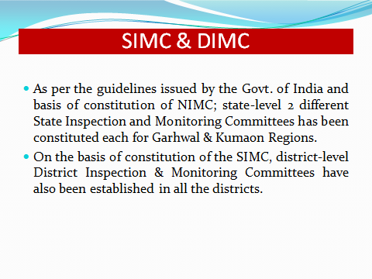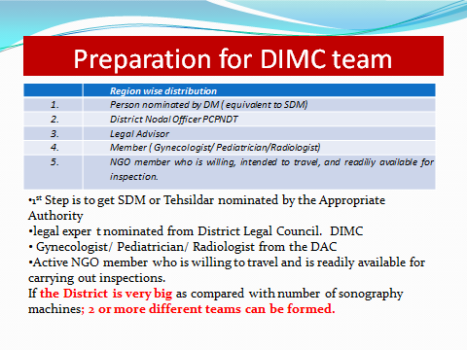
Slide:13 Slide:14
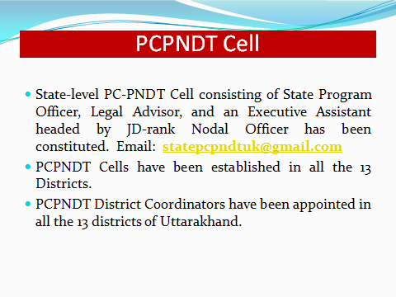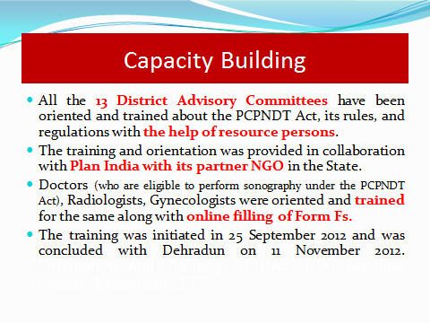
Slide:15 Slide:16
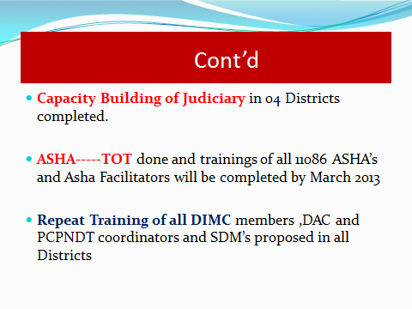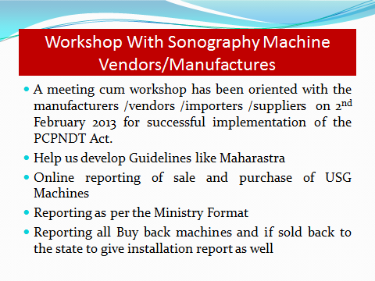
Slide:19 Slide:20
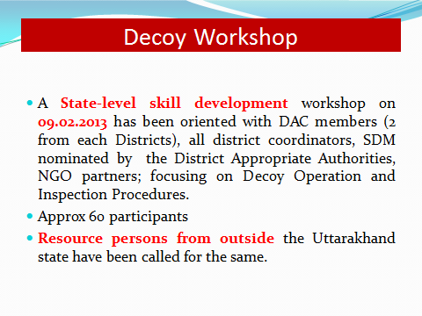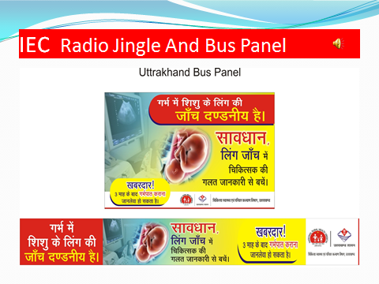
Slide:21 Slide:22
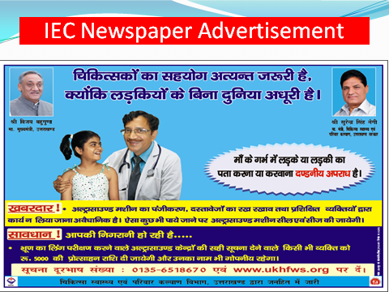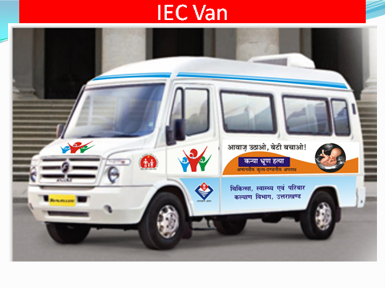
Slide:23 Slide:24
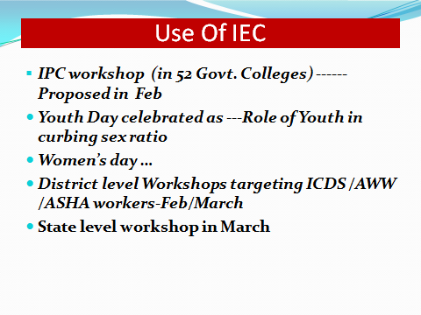
Slide:25 Slide:26

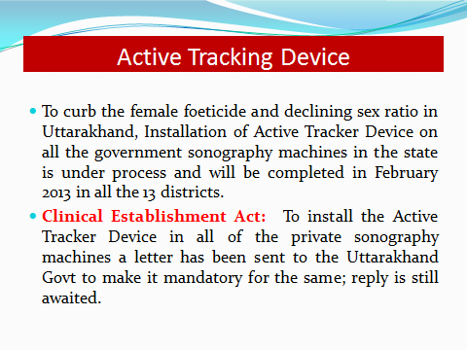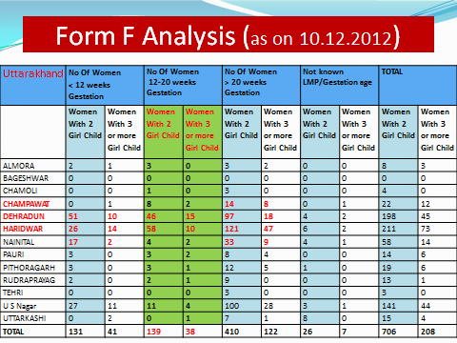
Slide:27 Slide:28
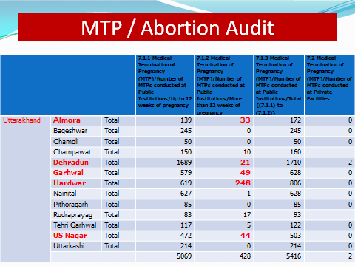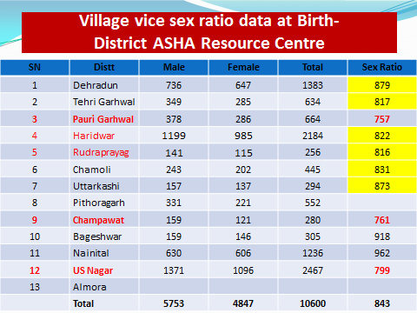
Slide:29 Slide:30
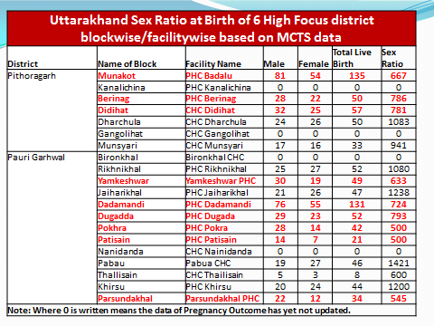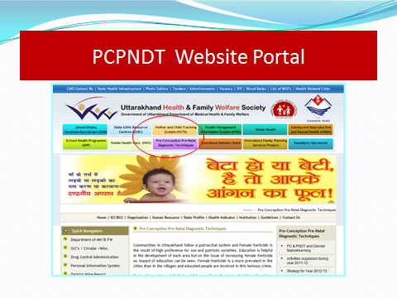
Slide:31 Slide:32
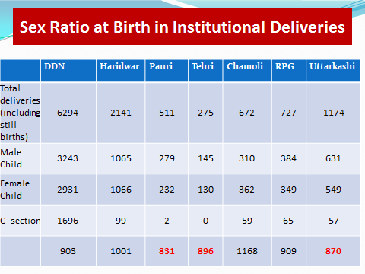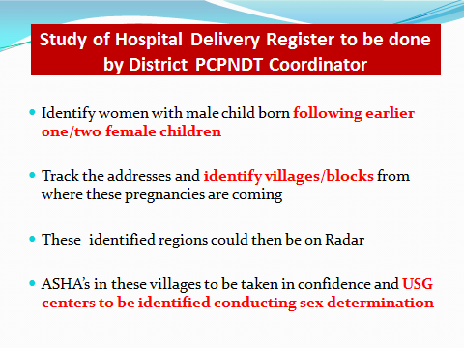
Slide:33 Slide:34
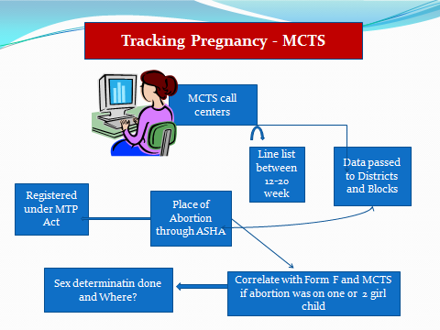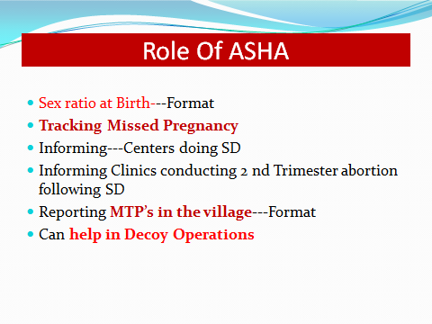
Slide:35 Slide:36

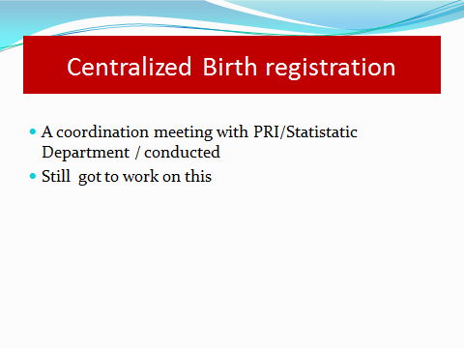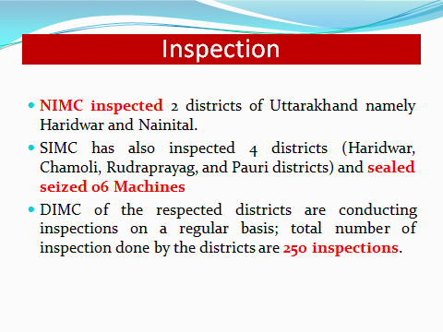

Slide:37 Slide:38
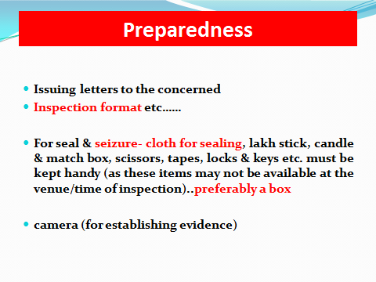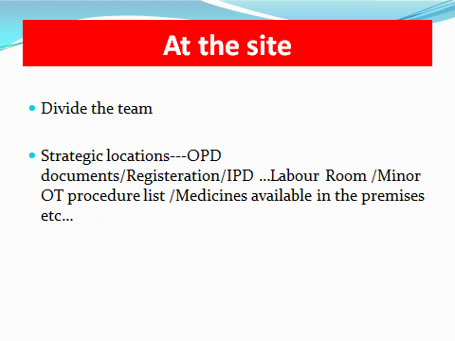
Slide:39 Slide:40
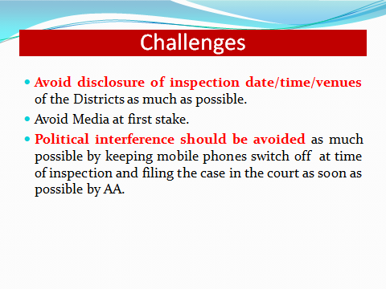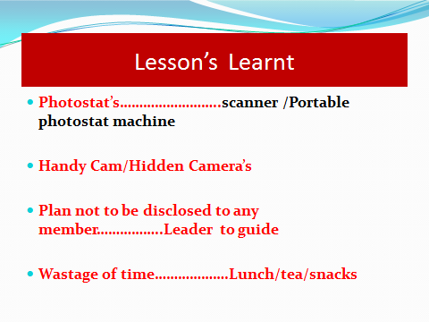
Slide:39 Slide:40
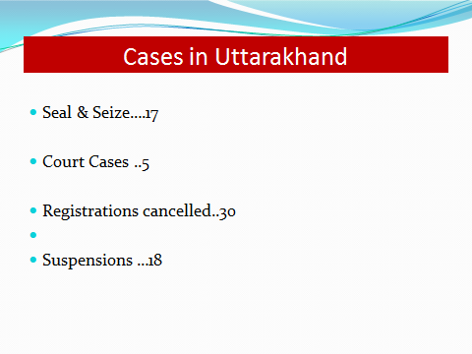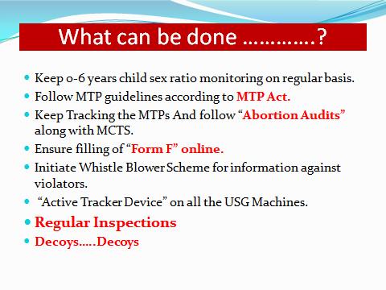

Slide:41 Slide:42
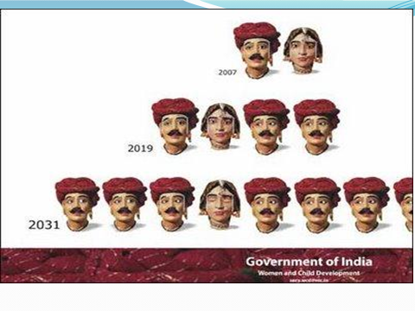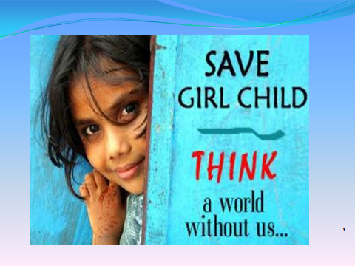
Slide:43 Slide:44

Post Lunch Session:
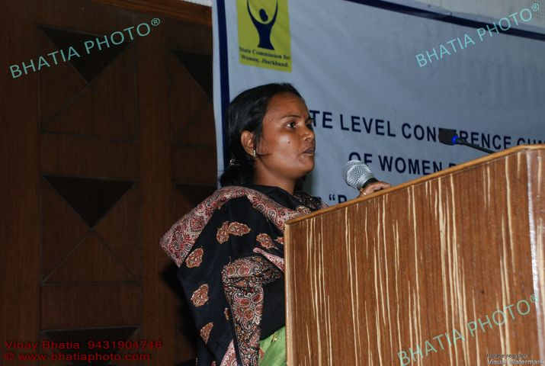
After lunch Faguni Devi from Dhanbad recited her story, she belongs to the Harijan community. Post marriage, when she became pregnant her in-laws forced her for sex selection test. Fearing a female child she was forcefully given medicine to terminate the pregnancy. The foetus was killed inside the womb. Upon lodging a FIR against her in-laws she was pressurized to withdraw the case. The husband was arrested and sent to jail for the crime. One month later her husband was released and now she has been falsely implicated in a theft case. She raised a question at the forum about what she can do about the situation she finds herself in. If someone comes forward to help her, they are threatened. She is now pregnant for the second time, how she can cope with the situation presented with.
- Health Specialist Dr. Madhulika Jonathan,Unicef, Jharkhand:

Taking further the discussion on what can be done, Dr Jonathan underlined the initiatives that can be taken for increasing the effectiveness of the implementation of the PCPNDT Act, 1994 focussing on the Commission state level network “Women Power Network” and the district health administration.
Main Highlights:
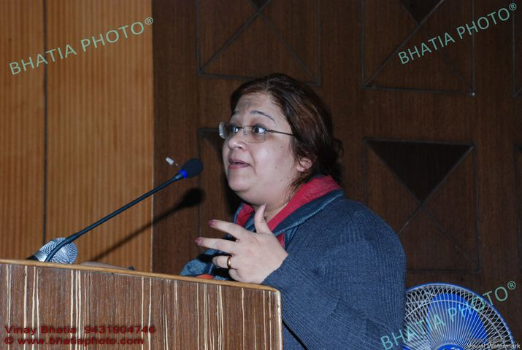
- The initiatives taken by the network is appreciable but at the same time it is also important to focus on the nature and effectiveness of the initiatives undertaken and the results thereof.
- Concerted and continued efforts are required for providing training to the communities, political leaders, health service providers, local administration, and civil society organizations for their sensitization and also to instil a sense of accountability.

- Under the PCPNDT Act, the filings of the Forms F by the registered clinics needs regular monitoring and follow up and time to time analysis.

- Working in close collaboration with Sahaiyyas, Aasha, Panchayats will ensure their active participation and involvement and will go a long way in moving towards the attainment of the objective.

- Systematized monitoring & supervision of the pregnant mothers, their identification, their health related problems and solutions

- Efforts directed towards breaking the chain of those involved in conduction pre conception and pre natal sex selection tests.

- More concerted efforts for making the Women Power Network active & effective in the above mentioned areas.

Main focus of the Presentation:
- Monitoring the initiatives and activities of NGOs, CBOs, Doctors & Medical/Doctors Associations & others.
- Sensitization of the community leaders.
- Through interstate cooperation, collection of all round information on pregnant mothers in those districts which are in close proximity with borders of other states.
- Analysis and evaluation of the filed Form F as per the provisions of PCPNDT Act, 1994. Supervision of the incoming information is also to be kept.
- A close monitoring and supervision of the efforts taken in the direction of complaints filed by the women complainants and in cases of exploited pregnant mothers is to be regularly done.
- Appraisal of the justice done in cases of pregnant mothers as victims which has come up before the courts and also ensuring that appropriate help whenever needed is made available.
- More active efforts to be taken to break the chain of criminals involved in crimes of sex selection tests.
- Active supervision of the pregnant mothers and status of birth rate with the help of ground level functionaries and PRIs representatives.
- More initiatives to be taken for awareness and trainings of persons and officials associated with services such as judiciary, members, district level legal services authority and other appropriate authorities.
- Identification of reasons behind uneven birth rate in specific communities, castes, family.
- Registration of Applications received by local administration.
- Guidelines for rejection/acceptance of applications received for providing grants.
- Improvement at the level of genetic counselling centres, genetic clinics and labs by local administration.
- Appraisal by the local administration of the cases on-going in the courts.
- Fixing of accountability by the local administration for supervision of illegal clinics, ultrasound centres, diagnostic centres and also implementation of the provisions for punishments under the Act.
- All round training for dissemination of awareness on violations of the Act for conducting pre conception and pre natal sex selection tests by the district administration.
- Role of district administration is important in the area of actions initiated on the comments Advisory committees on suspected centres and on reports of the Advisory committees on the clinics.
- More cooperation and coordination between Women Power Network and Advisory committees.
- More awareness on the Women Power Network to be created.

Presentation given by: Dr. Madhulika Jonathan
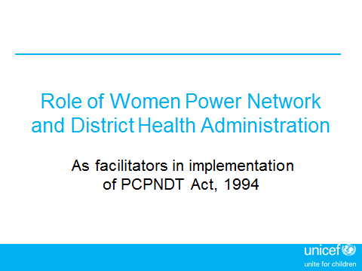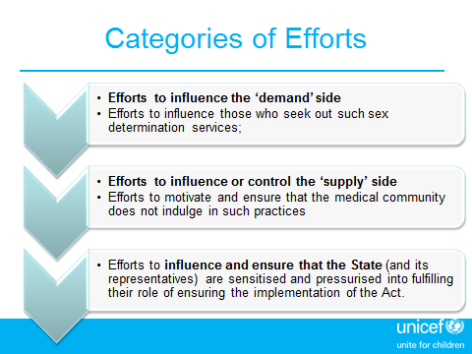

Slide:-1 Slide:-2
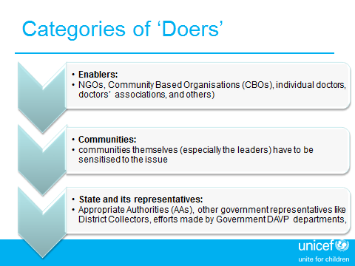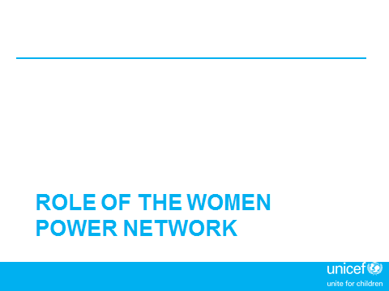
Slide:3 Slide:4
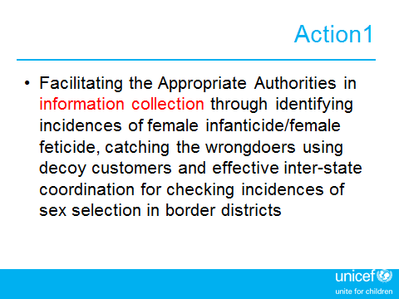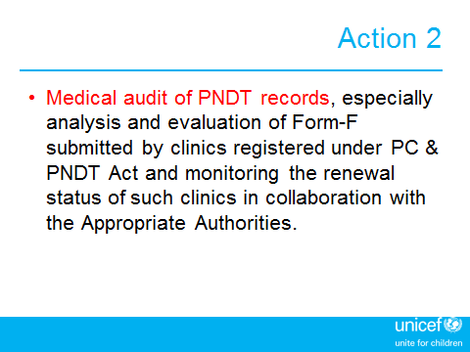
Slide:5 Slide:6
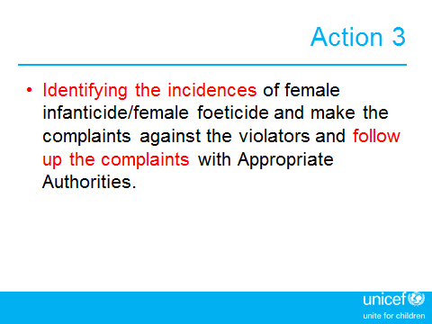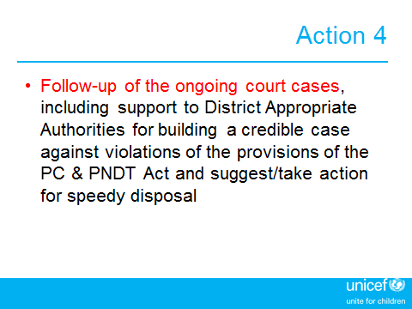
Slide:7 Slide:8
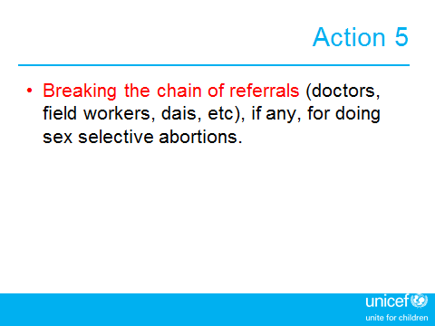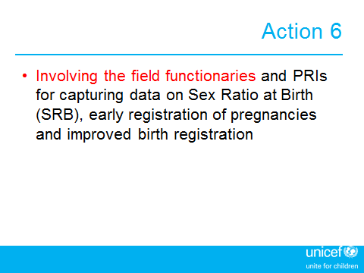
Slide:9 Slide:10
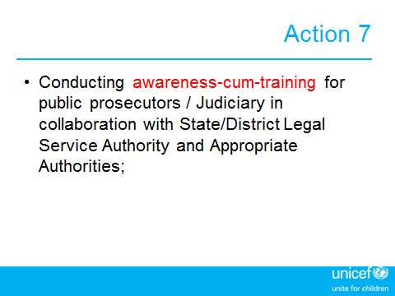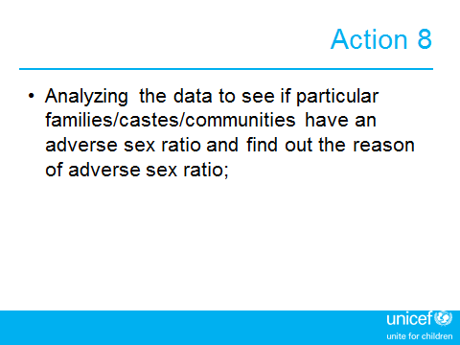
Slide:11 Slide:12
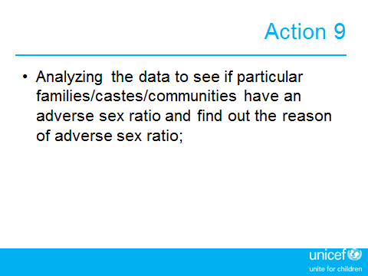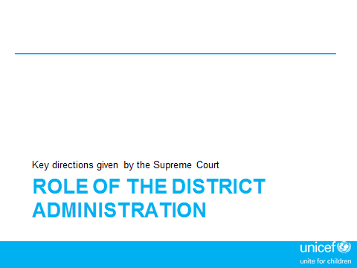
Slide:13 Slide:14
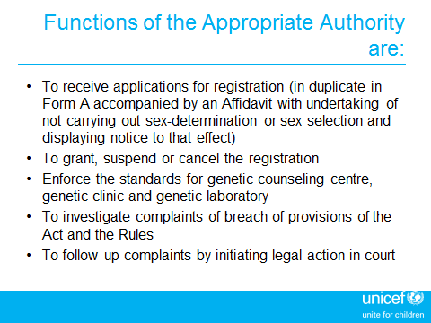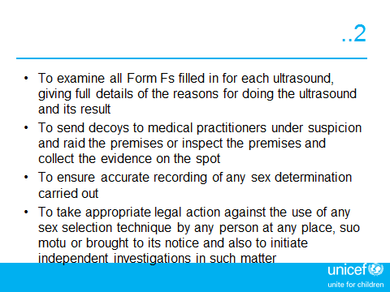
Slide:15 Slide:16
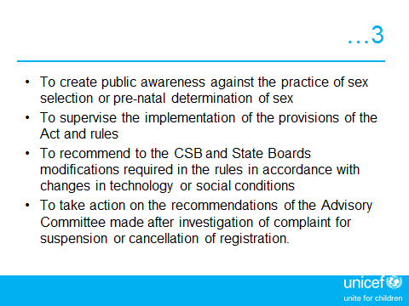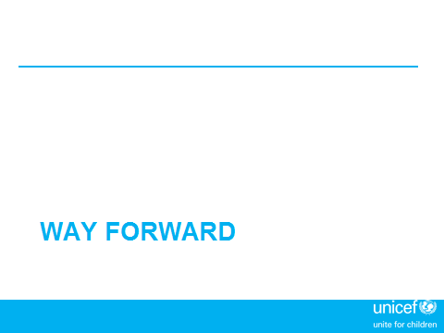
Slide:17 Slide:18
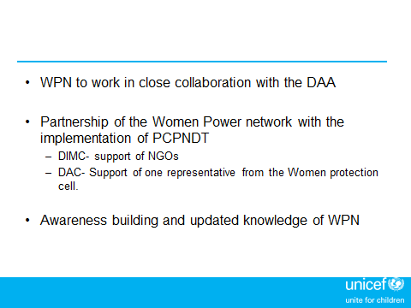
Slide:19 Slide:20

Presentations: Way Forward (Group Discussions)
Opinion of participants :(Based on Group Discussion with invitees):-
Opinion of Group “A”:-
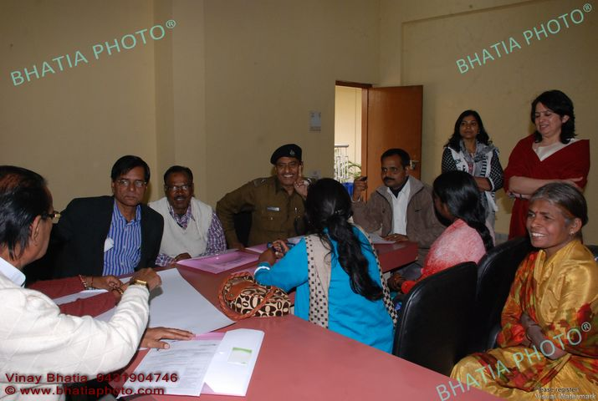
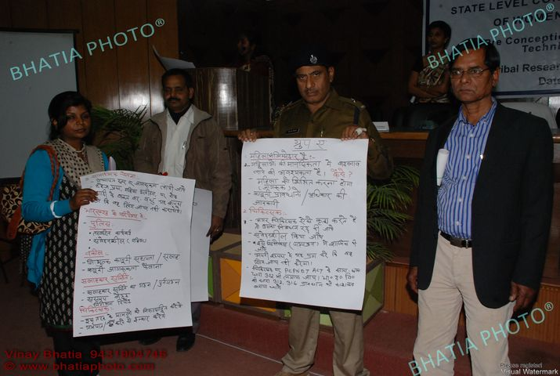
- Aware and educate the women about their provision and their rights.
- Introduce the issue of pre natal test and sex selection test in the syllabus of medical Institutes
- On manifest doctors implement the IPC 302, there should be provision of IPC 312 and 316 for them.
- Awareness on issues of women, dowry prohibition, and women atrocity should be come at the level of Panchayati Raj Institutions.
- Provision of oath at the time of marriage for the bride and groom.
- Arrangement of the provision for free of cost lodging of complaint by women.
- Civil society takes initiative in identification of non-registered USCs and brings the information in proper platform.
- Society will show their active participation in this area.
Opinion of Group “ B”:-
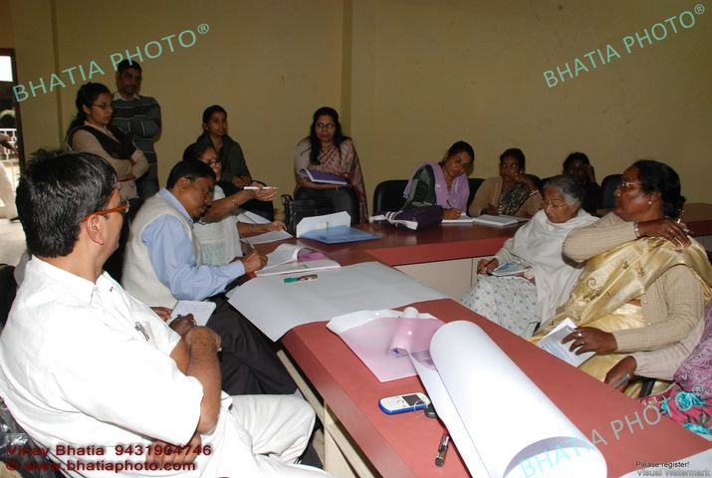
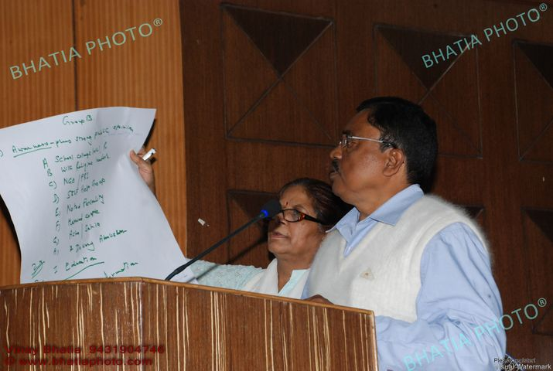

- Change the mentality of society towards the girl child.
- Inspire the students of college and school.
- Take help from self-help group, NGO, PRIs member.
- Inspire to married family.
- Protest against dowry tradition.
- Monitor the pregnant women and information of newly marriage.
- Make accountable and responsible to every class of society.

Opinion of Group “C”:-

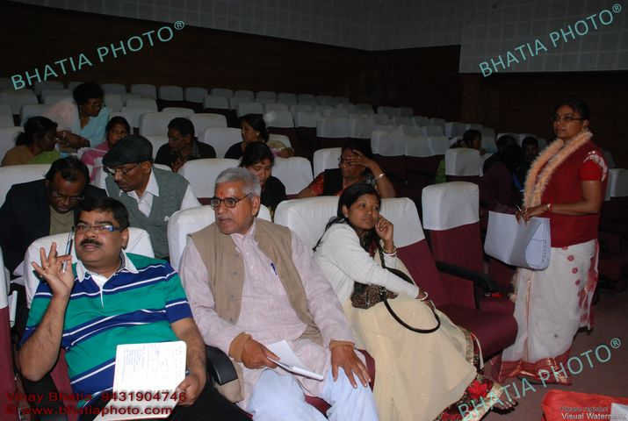
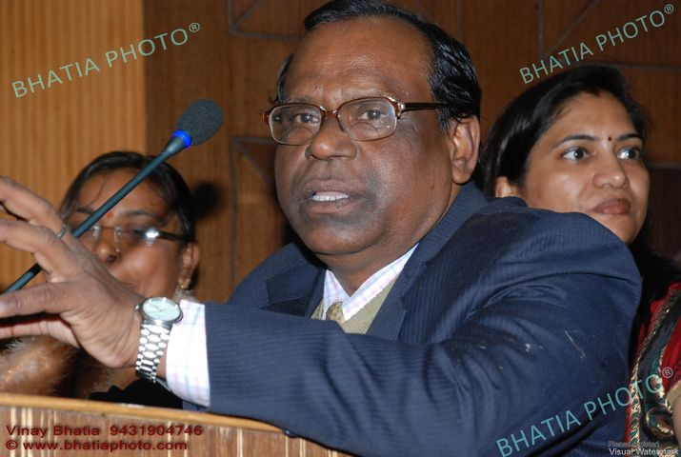

- Police should give respect and safety to women complainer.
- Fast action on application of women complainer.
- Timely settlement of the case/complain.
- Training for working NGOs.
- Co-ordination with PRIs member.
- Regular inspection of USCs, after violation of act provision of punishment.
- Define the meeting of state advisory board.
- Define the minimum amount for open the USCs.

Vote of thanks:-
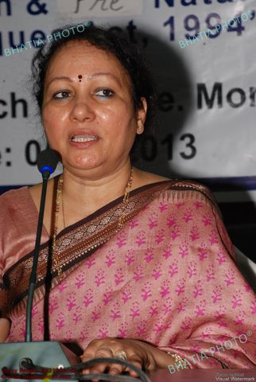
At the end of programme vote of thanks was given by Dr. Hemlata S Mohan. She said that in society everybody is facing these challenges. Statistics of female infanticide is going dangerous day by day. We need to co-ordinate with each other and make us accountable and responsible for better implementation of the provision of PCPNDT Act. We all are able and responsible citizens and require to act responsibly. Wherever illegal USCs are found, stand up against such unsocial acts and lodge complains on proper platform. If required or need be then write to the commission. Connect yourself with Women Power Network, members of the network take an oath that at least 3 cases of women atrocity/exploitation will be identified by them. The commitment to work for the socio-economic empowerment will play a constructive role in strengthening of the Act as PCPNDT act.

----------------------------------------------------------------------------------------------------------------------------------------------------------


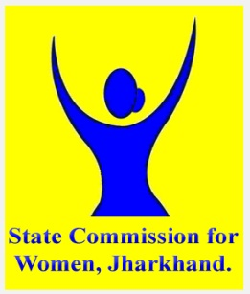
  - Agenda

State Level Conference Cum Workshop of Women Power Network
on Pre Conception & Pre Natal Diagnostic Techniques Act, 1994
Date: 5th Feb 2013
Venue: Tribal Research Institute, Morabadi Ranchi
Time | Programme Details | Facilitator
10:00-10:45 AM | Registration & Breakfast | Ms Rashmi, Ms Soni, Ms Manju
10:45-10:55 AM | Introduction and welcome | Ms. Shashi
10:55-11:10 AM | Opening Address: Smt. (Dr.) Hemlata S Mohan, Chairperson, Rajya Mahila Ayog, Jharkhand  Objectives of the consultation  - formation of network (online registration)  - capacity development of members etc. along with key initiatives of Ayog | 15 min
11:10-11:25 AM | Address by Special Guest: Mr Job Zachariah, Chief, Unicef Jharkhand | 15 min
11:25-11:40 AM | Address by Distinguished Guest: Smt Mridula Sinha, Principal Secretary, Social Welfare & Women & Child Welfare Department | 15 min
11:40-11:55 AM | TEA BREAK
11:55-1:25 PM | PCPNDT Act:  - The Act, Provisions (structure at State, District)  - Status of Implementation in Jharkhand | Resource Person: Ms Debjani Khan, Project Manager-LGBB, Plan India
1:25-2:15 PM | Inter State Cross Learning:  Status Review: Jharkhand vis a vis other states: Uttarakhand | Dr Saroj Naithani, Jt Director, State Nodal Officer, PCPNDT Cell, Uttarakhand
2:15-2:45 PM | LUNCH
2:45-3:15 PM | Role of Women Power Network and District Health Administration: As facilitators in implementation of PCPNDT Act, 1994 | Ms Madhulika Jonathan, Health Specialist, Unicef Jharkhand
3:15-3:45 PM | Way Forward: (Road Map)  - Group Discussion | Representatives of Police Mahila Koshang, District Civil Surgeons/Dist Committees, NGO Representatives (including members of District committees under the Act)
3:45-4:15 PM | Action Plan: Sharing & Reflection (Presentations)
 | Vote of Thanks

