Situation analysis report
Context –
Situation analysis of the target villages of three states was the first step to have an in-depth understanding about the issues associated with migration , health socio economic standard of target community. Various methods used to do situation analysis helped to bring out issues and create scope for focused intervention.
The outcome of the situation analysis helped to draw an action plan for the respective community.
Profile of Target Villages visited during situation analysis -
Date of visit | Name of the organisation visited | Name of the village visited | Total HH | Type of community | Activities carried out to do situation analysis
21/04/2015 | Chetna / Bastar | Maolivata | 139 | Gonda ,Thakur , Maria | KAP survey , focused group discussion with community leaders , prepare seasonal calendar ,HH viist
22/04/2015 | Chetana | Dilimili | 82 | Madia ( gonad) Sundhi (sc)
10/5/15 | Sramajibi mahila samiti / jamsedpur | Satpura / Bari GP | 46 | Adivasi HO community | KAP survey , focused group discussion with community leaders , prepare seasonal calendar focused group discussion with adolescent girls & women , case study , HH viist
11 /05/15 | SMS | Kasruwan / Bari gp | 157 | Adivasi ( munda ,Ho , nayak)  OBC , Lohar
12/05/2015 | SMS | Nua gaon / Balijor gp | 250 | Adivasi(HO, Nayak )  OBC – Pradhan , mahato
14/05/2015 | JJVS /Kansbel | Tita pakera | 70 | Adivasi (ORAU Christian ) | KAP survey , focused group discussion with community leaders , focused group discussion with adolescent girls , case study
14/05/2015 | JJVS /Kansbel | Basen Niche tola | 70 | Orau | KAP survey , focused group discussion with community leaders , focused group discussion with women
19 /05/2015 | JJVS /Goleng | Chota golenda | 57 hh | ORAU , Harijan , SC , lohar , | KAP survey , focused group discussion with women ,House visit , meeting with adolescent girls , one to one meeting with village leader
20/05/2015 | JJVS /Goleng | Sarai tola | 55 hh | ORAU , Harijan , SC , Nagesia | KAP survey , focused group discussion with women ,House visit ,
28/06/2015 | ISD /Kandhamal | Kudi gunja | 27 | Kandha , ST | KAP survey , focused group discussion with women ,House visit , Transit walk
29/05/2015 | ISD /Kandhamal | pljheri | 70 | Kandha ,ST | KAP survey , focused group discussion with women

Steps followed to do situation analysis -
- Organised Structured meeting with community representatives comprises village pradhan called MUNDA , SMC head , AWW , Ward member ,representatives of migrant family to have open discussion about socio economic condition of the villagers , govt support programme and its reach out , details about migration , disease pattern
- Discussion followed with developing seasonal calendar which helped out to map the season wise engagement of the community.
- selective House hold visit for KAP base line survey
- focus group discussion with adolescent girls to know menstrual hygiene practice
- case study collection
Key findings (target community)
Chetana | Sramajibi mahila Samiti | Jjvs / Kansabel | Jjvs/goleng | Isd
Majority of the target community are belongs to Adivasi and the Gonda communities are been taken as one of the backward community among adivasi. | Mixed Adivasi with majority of HO community who are one of the most vulnerable communities.  There are other Adivasi like Nayak who have better life. also there are OBC and SC community | This is also mix Adivasi community like Nagbanshi, Kounar & ORAU .among ORAU there are both hindu and Christian . majority of migration occurs among the ORAU community. | This is mixed Adivasi community dominated with ORAU , followed by SC and few other caste people . Majority of migration occurs within ORAU community. | Majority of the target community are mixed both SC & ST but dominated with Kandha

Livelihood
- Paddy cultivation is the prime means of support for the family where the family ensure food for the year. As majority are having small land and there is no irrigation facility so they go for single crop cultivation which is not enough for the year.
- Irrespective of all class both men and women of the family engages in agriculture land. Even in the Ho community young children are been engage in livelihood activities.
- Those who does not have land depends on daily labour .but there number is very few in the target village.
- Second major livelihood support is collection, process and sale of forest product where women, children and elderly person of the family gets engaged. In this work most deprived advise community like HO, ORAU are been engaged. Collection of leaf, seasonal forest products like summer time they collect tamarind, mahul, chiroungi fruits along with some other fruits. ( Chhattisgarh & Jharkhand)
- Where as in Odisha Kandha tribe cultivates goes for cash crop like Turmeric, mustard which they do after the paddy cultivation.
- The family who collect the forest products also do processing & sale to the middle man either against of rice or money. The barter system still exists in all Adivasi communities of across three states. Example after collecting sal leaf (one type of leaf used to make leaf plate) they stitch the plate and sale.

At the end of day a HO lady earns Rs 90/- to Rs 100/- rupees by sailing two /three hundred stitched leaf plates which includes collection of leafs from forest ,processing & stitching . for 100 pcs of stitched plate she gets Rs 30 /- which has market cost of Rs 200 /-
And it has great impact both on her health as well on child care .majority of small children of HO community found malnourished and left alone without care.

Similarly chiroungi a type of nuts used for sweet making and its market value per KG is Rs 500/- they sale against rice.

Along with income oriented activities women’s are engaged in collection of firewood, preparation of land for next cultivation. Over all round the year a women is engaged.

- Whereas the women of nayak and OBC community does the work from home. They are mostly engaged in processing work. Like example local tobacco factory provides both leaf and tobacco to prepare bidi (type of cigar ate made from kendulaf and tobacco) at home. For 1000 pcs of Bidi they get Rs 70/- . Working from home supports them both to take care of house as well to be part of income. That is why during house visit it was observed OBC and Nayak have better clean organised house than the HO. ( Chhattisgarh & Jharkhand) )

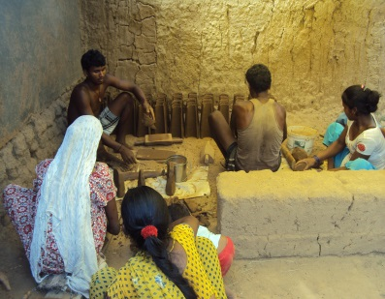
- Another type of livelihood support is making clay tiles where the ORAU family gets engaged in the summer time. It is family business where the entire family from children till old people participate. This is taken as skilful activities. at the end of day family could make Rs 500 / -
However all those work the Adivasi community does in lean period are labour intense work where total family gets engaged also there is health risk attach to this work but on return they do not get actual cost which they should . As because the total marketing of those products controlled by upper class and Adivasi does not have united approach so the business man takes advantage of this situation.

Health
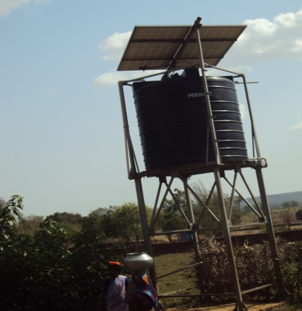
Health is determined by the food nutrition, health seeking behaviour and accessibility to govt health programmes of the target community. During field visit associated with interaction with community, KAP survey & house hold visit provided following information around health practice of target community across three states .

Hygiene practice of target community

Drinking Water
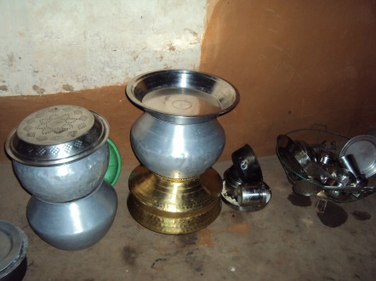
- Prime sources of drinking water collection are deep hand pump & open well. Both the sources have been taken as safe source because of the depth is concern. Surroundings of the drinking water sources are found clean. As majority of our target villages are hill area and less populated so there is no stagnant water or debris found around the water sources. In Chhattisgarh many places solar pump are been attached with hand pump to lift the water to overhead tank. So it helps children and elderly people to fetch the water from the pipe rather pushing handle to get water.
- Another good practice was observed cleaning of fetching pots. majority of community clean it every day before fetching of water ( KAP survey findings)
- As majority of families have no separate container to store so they use same fetching container for storing of drinking water. Wide face silver vessels are been used for storing of water and the containers are kept on ground so there is every possibility of children putting their hands to get the water.
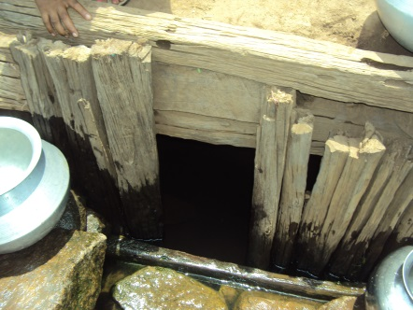
- The bigger challenge is drawing water from the container where there is no particular container to draw the water and they deep their hand in the water to draw. This is the major concern which makes the drinking water contaminated. Base on the KAP base line survey findings almost all the family are following same practice.
- Only in Kandhamal Odisha it was observed community using spring water for all purpose including drinking which is not safe.

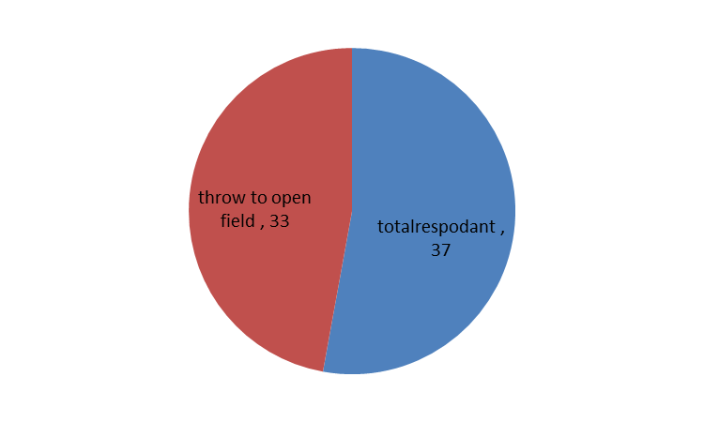
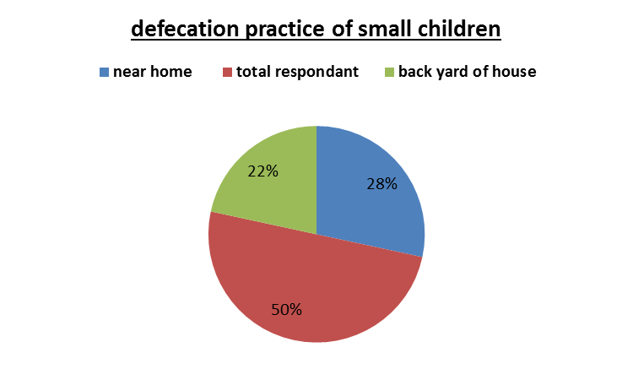
Sanitation practice link with children health.
- 100% community goes for open defecation. However they maintain distance go far forest area, land for defecation. But the small children defecate near the house and their faeces left for domestic animal like dogs, chicken to eat. Defecation & Disposal child faeces are big challenge. Base on KAP survey out of 37 respondent (mothers of < 5yr children) 28 children defecate close to house. similarly disposal of child faeces
Out of 37 family 33 families throw to open field. However both the practice has serious implication on child health. as result majority of children found with warm infection & anaemic.

Hand washing practice

Not a single family found following hand washing practice at critical time. Normal practice is to wash hand before food and after toilet with water. There are few families found using soap for hand washing. (KAP survey)
- Use of ash for washing hands is also prevailing in some families. The findings of KAP survey and community interaction provided useful information to design intervention around hygiene practice of the target community across five project area to reduce the morbidity rate among the target community

Menstrual hygiene practice

- It was observed different community following different practice to maintain their menstrual hygiene.
- Use of cotton cloth as absorbent is very common both with young girls and women across all the target community
- Only school going girls, and the girls who are earning are been found using sanitary napkin. Because it has link with accessibility and affordability in some schools there are provision of distributing sanitary napkin and the girls who are earning can spend some money to buy the napkin. Only in ISD /kandhmal during discussion with girls they shared another NGO named World vision is regularly distributing sanitary pad and washing materials for use.

During discussion with girls from different community following information gathered which needs to be address thoroughly to bring positive changes in adolescent health.

- Discussion on menstruation hygiene are limited both at house and also at institution level ( AWC , School) . the discussion was limited to only learning on how to tie the cloth or distribution of sanitary pad

- Girls who get infections or severe rashes does not know how to get proper treatment

- Majority of girls said that they have never taken any medicine and they just tolerate the pain or discomfort

- Most of the girls showed keenness in learning napkin making so that they can make it for themselves

- Almost all the girls expressed their desire to use napkins regularly if they are made available at affordable price

- Many times due to the information flood on HIV/AIDS, when women have any itching or rashes near their private parts they fear sharing that to any one or going to a doctor as it might be mistaken with HIV/AIDS

- Almost all women / girls wash the cloth in dirty water and the water sources far from community. during winter and rainy season it become difficult to go far so they use stagnant rain water to wash cloth.( KAP SURVEY)

- Disposal is an issue for women who use napkins regularly as there are no proper disposal facility that is why they throw in to bushes or to water sources particularly in to pond . No body burns the napkin as they have believed it brings infertility.

- Most of the girls wanted to know more on menstrual hygiene as they felt their knowledge on that is very limited

- There are various myths around food , social practice are prevailing around all the communities which has great impact on health of adolescent girls

Children health

Majority of children from Adivasi community particularly HO & ORAU community found with nutrition deficiency & malnourished. This is because of lack of maintaining diverse food habits it was more starch dominated and cleanliness was not maintained. Also it was found majority of children have not completed the routine immunization. Particularly the children above three years have not been covered under the immunization it was because mother does not know.

It was observed the AWC center are been set up in the area where more better up families or communities are living like where the accessibility to most needy community is big challenge . This is one of the reasons Ho community women finds difficult to such distance with her children. ( SMS /Jharkhanda)

Migration
There two types of migration observed in our all operational area across three states.
(1) One is seasonal migration which starts after cultivation from the month of Jan – June. In Seasonal migration people go for particular period to work and again comes back home. This is mostly to manage the lean period. Almost six month people go to work out side and bring back money. That bulk income is spend to repay the loan, repairing / construction of house, marriage etc. In this type of migration sometimes total family shifts along with children to work and earn. Though it is taken as safe migration mostly married, adult person goes for this type of migration.

(2) Another type of migration which also associated with human trafficking where the young children below 14/15yrs taken out side for work. This is done mostly with the neediest families like women headed families, land less families, families having more number of children engage their children as an earning member.in this case middle man plays crucial role with the consent of the family takes the children to outside. It was also observed majority of this cases own relatives / family members who already been working outside play role of mediator and family trust them to send their children. In this type of migration small / young girls are been preferred to be send by families because they sustain for long time and send money regularly to families . This middle man has link with some place ment agencies working in Big cities like Delhi , Chennai , Bangalore to whom they hand over the children and get commissioned .

Another type of children migration which is done through peer pressure is more common with adolescent groups are more seen during post examination and festival time. During interaction with community and family members of the migrant children came to know after examination when result was out if child is failed for him / her it become self-image crisis. The middle man / peers takes the advantage of that situation motivates the children to fled away from village. Similarly during festival season in order to fulfil big demand like purchase of costly dress, mobile they go outside to earn and full fill the demand.
• Though People from both SC & ST community going outside for work but the significant part is only male folk of OBC, SC community goes outside to work women stays back at home to take care of family.
• Within deprived Adivasi community like Gonda from Baster, HO from Jharkhand, and ORAU from Chhattisgarh, kandha from Odisha follows various pattern and it depends on the family financial requirement sometimes whole families migrates , or they send their children both boys and girls going outside in search of work.
• Lack of steady earning opportunity absence of Govt poverty eradication programme like MNREGA, Antodaya yojana are the major driving force for people to go outside for work.
• Due to discontinue in the study like Present universal education system where tribal children find alienated lose interest to continue. So this one of the major reason for the small school going children to drop the school and goes to work out side.

Types of migration and its impact observed

When male members of family migrates | Women of family become in secured  Women are forced to depend on other male who try to take advantages  It has impact in children health.  Male gets in to extra marital relationship and it has impact on increase number of HIV and other infectious diseases.  Family suffer extreme poverty.  Male gets in to alcohol and other bad habits  Domestic violence in the family increased
When children migrates | Drop from education.  Could not adjust to new host community  They faced big cultural gap.  girls are been engaged in to riskful activities like child prostitution.  Children faced accident and been abused by different persons
When total family migrates | It has impact on children education and health  Living in unhealthy atmosphere and hard labour affects to the health condition of family  Children are become more malnourished.

Drupadi Gope widow lady from Village Stapuri shared her daughter Savitree 13yrs old with her eight friends have been migrated to West Bengal .since last two years she is going work in brick factory. Her aunty who last twenty years going for migration took her for this work. Last year Savitree brought Rs 7,000/- brought home as savings from working outside. ( SMS /Jharkhanda)

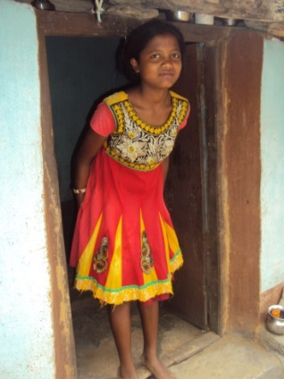
Story of Sar swati -

Sonu Malgandi male 30 yrs old living in Kasurwan village has four children .saraswati is her eldest daughter who is fourteen years studying in class eight. Sonu has small land which is not adequate to feed entire family for the year. Every year after cultivation season is over he with family goes to Raipur to work in brick construction factory where along with his wife daughter saraswati also put in to work. Every year he spend almost six month outside so saraswati could not continue her study. Now she has stopped her school and helping mother in house hold work. The reason of more number of girls drop out is to support the family in house hold as well livelihood work. ( Chhattisgarh)

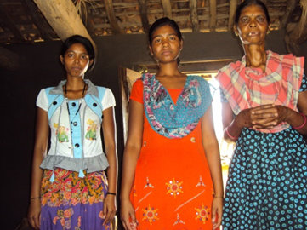
Ranjita Topo, 17yrs old girl, mother Sabestio Topo who is widow, and one sister living in Titapakhir village. Dhananda known person to family took Ranjita to work in Delhi With a promise she will be able to earn good money for family .almost six months Ranjita worked as domestic worker. But she could not cope with Delhi climate became sick and back home with the support of the organisation JJVS. after returning home she came to know Dhananada has taken all her salary from the employee and dis not paid to her family

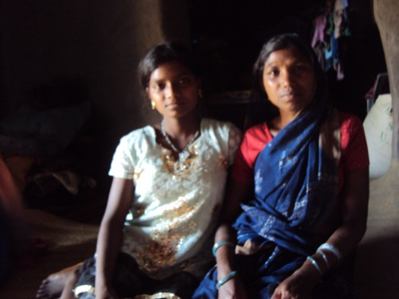
Asanti Bai 14yrs old girl was taken by her sister in law who already working in Delhi. She sold Asanti to placement agency in Delhi. As Asanti was minor girl so placement agency found difficult to engage her in work. And started torturing her. Somehow Asanti could manage to inform her parents about her situation. With the help of JJVS /Goleng and local police she was rescued from Delhi. During discussion with her parents they shared she will be put in to school after vacation is over.

Case study
Menstrual hygiene practice of HO Adivasi girls
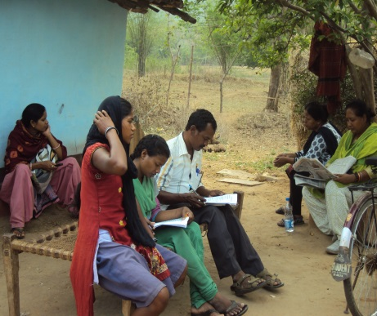
Rui Bari Gope, 17 yrs. old girl of Satpura village leaves with her two younger sisters and one brother. The family have lost their parents who died of some unknown disease. So Rui bari became the guardian of the family. They have little land which is not adequate to feed the family round the year so Rui crush stones to make stone chips, collects forest products to fill the lean period.
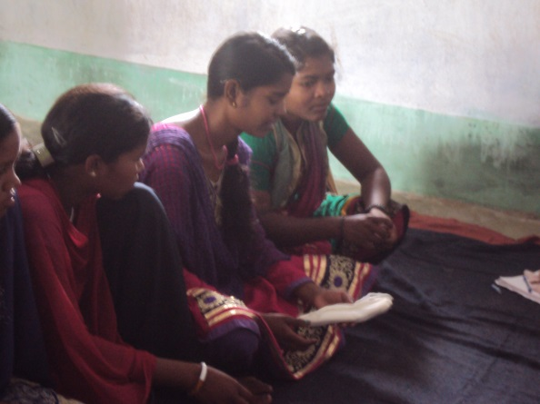
Regarding her menstrual hygiene practice she shared not only she even other HO girls never use extra absorbent to soak the menstrual blood. They allow it soak it in undergarments (panty) they wear. That is the reason during menstruation time they change the panty frequently. And it became very much difficult in winter time as she has to go to pond more than three to four times to wash under wear. There is practices not to wash menstrual cloth near hand pumps as the community collect water for drinking purpose as well it is difficult to maintain the privacy . When she was asked whether she has interaction with other community girls about their menstrual practice. She shared yes she knows about the sanitary pad. But the married women of the HO community use old cotton cloth as absorbent. it is not only Rui bari even during interaction with other Ho girls they also expressed same practice . Some girls used two panties to check bleeding but they do not have practice of using extra absorbent. The reason is lack of awareness and not availability of cotton cloth compels them to use whatever existing materials they have.
Suru Bodra studying in class ten drops her class during her menstruation days. though there is provision by state ad well as national level to keep sanitary pad in the upper primary school but that was not followed by the schools.

Action suggested -
 | out come | mile stone / list of activities to becarried out | Total no | support group | Requirments | April | May | June | July | August | August | Sep | Oct | Nov | Dec | Comments
 | set up village level migration tracking committee .and support for organising monthly situation review of migration along with migrant families . | 1) organise meeting involving all category people of village to discuss the migration issues and to form committee  2) periodic meeting of the committee  to support them for monitering the migrant isssues | traget village | village head , AWW , | register book , meeting minutes record book , banner |  | formation of migraton watch committee |  | meeting |  | meeting | meeting | followup meeting and moniter record maintaining process
 | registration of migrant people start at village linkages with panchyat local police stataion
 | village level display of migration registration
 | Balika mandals are been set up at fall target villages and girls learned to maintain safe menstrual hygiene practice.,tips about safe migration , and first aid | 1) review the existing Balika mandal fromed by AWW & ensure involvement of HO adivasi community girls  2) Identify peer leader to work as peer motivator  3) training of peer leaders on leadership & key health hygiene issues | targetvillage | AWW , ANM | training material , promotion materials |  | Formation of group & prepare list of girls |  | Training | Trainng
 | Mothers improved their knowledge & start practice on following aspects -  1) maintain safe water chain  2) set up hand washing points at home and follow hand washing .  3) improve the nutrition value of the children food using local availble vegetables | 1) monthly one hour mothers meeting at AWC practical demonstration on safe water chain , preparation of low cost nutrious food  hand washing practices etc | Target villages | AWW , ASHA ,ANM |  |  | cont | cont | cont |  | cont | cont | cont | cont
 | set up learning resource center at one schools & monthely twice learning activities with students continue | 1) Organise meeting with school SMC & teachers to share the idea of running of learning center  2) devlop session plan for school  3) letter to BEC and share the session plan  3) identify student moniter to run the larning center | Target school | SMC , teacher | promotional materials  prizes ,register book
 | Set up hand washing points at three school and ensure children practice hand washing before mid- day meal and eat in clean place | 1) practical demonstration to students on handwashing steps  2) iddentify health moniter to moniter the hand washing , school cleaning activities  3) ensure availbility of soap for had washing | target school | SMC , teacher | soap ,broom , prizes
4 | Providing career guidance and information regarding various schemes |  | Target school |  |  |  |  |  |  |  |  |  |  | 1
8 | Linkage & convergence with Govt Schemes |  | target village
10 | design and printing of IEC material | selection of IECon Migration issues , hand washing , hygiene promotion | 2 set
12 | Report and documention |  | 3 times |  |  |  |  | 1 |  |  |  | 1 |  |  | 1

End of document

